Name: Sagar Ganesh Sharma
Employee ID : 102033
- Que. What is a Transaction Reversal ?
  - A message from the transaction originator to the transaction authorizer indicating that any database impacts from an earlier transaction should be reversed because the transaction either could not be completed or was completed incorrectly
  - Reversals are generated by Device Handler processes when transactions fail to complete as authorized. Reversal (0420) messages are sent by the Device Handler process to the Authorization process as shown below.
  - 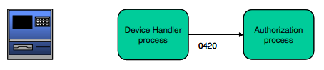
  - COMP : Transaction completion message generated by an ATM connected to BASE24-atm. The Device Handler process uses this message, in the native-mode language of the ATM, to determine whether a reversal (0420) transaction must be generated.
  - IRVSL : Transaction reversal sent to an interchange. The Interchange Interface process reformats STM messages (0420-series) into messages understandable to the interchange.
- Reversal Flow:
  - Approved by Host-Transaction Reversed-Completions Required
    - 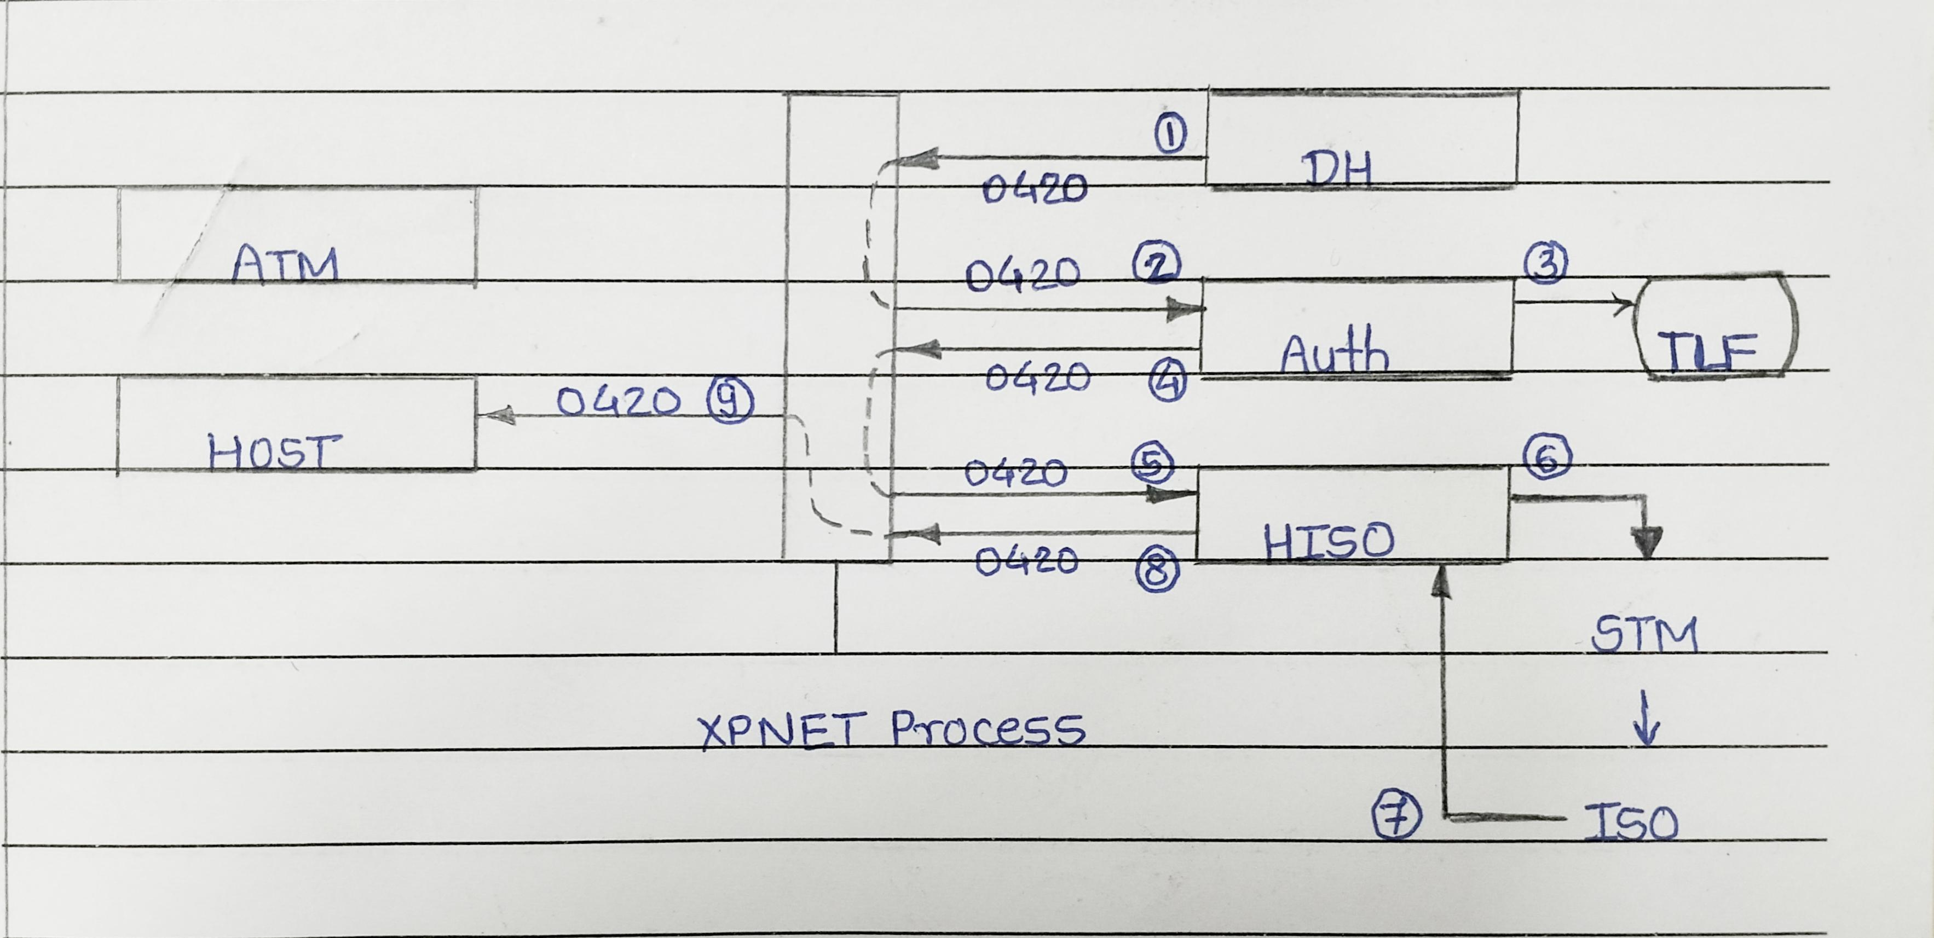
    - The Device Handler process generates a 0420 reversal message and sends it to the Authorization process.
    - The Authorization process logs the reversal to the TLF and sends the 0420 reversal message to the Host Interface process.
    - The Host Interface process reformats the internal message into an external message and sends the 0420 reversal message to the host
  - Approved by Host - Transaction Reversed - Completions Required- Host Acknowledgments Required
  - Approved by Host - Originates at Acquirer Host - Transaction Reversed - Issuer Host Requires Completions
  - Approved by BASE24-atm - Transaction Reversed - Completions Not Required
  - Approved by BASE24-atm - Transaction Reversed - Completions Required - Host Acknowledgments Required
  - Approved by BASE24-atm - Originates at Acquirer Host - Transaction Reversed - Acquirer Host Requires - Acknowledgments - Issuer Host Does Not Require Completions
  - Approved by an Interchange - Transaction Reversed - Advices Required - Advice Not Sent
  - Approved by an Interchange - Transaction Reversed - Advices Required - Advice Sent
  - Approved by an Interchange - Surcharge and Issuer Fee Applied - Interactive Response Notification Processing - Cardholder Cancels Transaction
  - Approved on Another Logical Network - Transaction Reversed
  - Acquired at the ATM - Approved by a Customer - Specific Process - Transaction Logged to TLF - Transaction is Reversed
  - Definitions-based Model (Declined by Telco)
  - Message-based Model (Declined by Telco)

- Message Types for Reversals:
Message Type | Description
0420 | Reversal — Indicates a transaction wasn't completed as authorized.
0421 | Reversal Repeat — A reissue of the reversal message  (0420) indicating that a transaction was not completed  as authorized.
0430 | Reversal Response — An acknowledgment of receipt generated by a host or co-network in response to a reversal (0420). This type can also be sent by an Interchange Interface process.

- Reversal Codes:
  - RVSL-CDE in Internal Message Format
    - A code indicating the reason for the reversal or adjustment.
    - This field is used only for reversal (0420) transactions
    - Values for reversals are as follows:
01 | Timeout
02 | Command Reject
03 | Destination Not Available
08 | Customer canceled transaction
10 | Hardware Error
20 | Suspect Transaction (Machine could not able to identify the transaction)
21 | Message Authentication Code (MAC) failure
22 | MAC Key synchronization Error
23 | Message replay error
24 | Invalid MAC
30 | Funds not approved for Load Value
31 | Load Value not successful
40 | Split Transaction Routing enabled; secondary service  not approved

- Que. When and How Reversals Happen?
  - Ans:
  - Device Handler Timeout:
    - If the Device Handler times out but later receives a response from Authorization, it sends a reversal (0420).
  - TLF Unavailable:
    - If TLF (Transaction Log File) is not available, reversal is sent to Authorization without token data.
    - Authorization logs it as an exception for manual reconciliation.
  - Reversal Options in Token:
    - TLF token contains reversal processing info.
    - Device Handler adds this token to the message before sending.
  - Outbound Timer Limit = 0:
    - Host Interface fails the transaction if timed out.
    - Sends reversal if a late response is received.
  - EXTRN-RQST-TIMEOUT = 1:
    - Host Interface fails the transaction and sends a reversal to the host.
    - Drops any late responses from the host.
  - ATM Deposit Cancelled or Failed:
    - ATM automatically sends a reversal if:
      - Customer cancels the deposit.
      - An issue occurs during deposit.
    - Standard reversal steps are followed.

